**Chapter 2**

**Vectors in Space**

**2.6 Quadric Surfaces**

**Section Exercises**

**For the following exercises, sketch and describe the cylindrical surface of the given equation.**

303. **[T]** 

Answer: The surface is a cylinder with the rulings parallel to the axis.

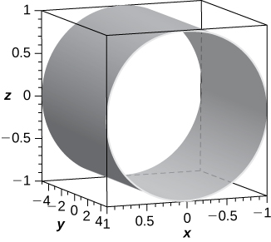

304. **[T]** 

Answer: The surface is a cylinder with rulings parallel to the axis.

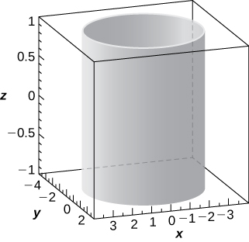

305. **[T]** 

Answer: The surface is a cylinder with rulings parallel to the axis.

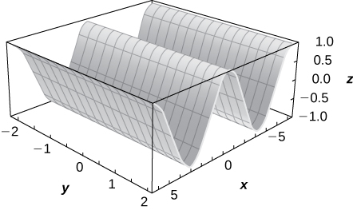

306. **[T]** 

Answer: The surface is a cylinder with rulings parallel to the axis.

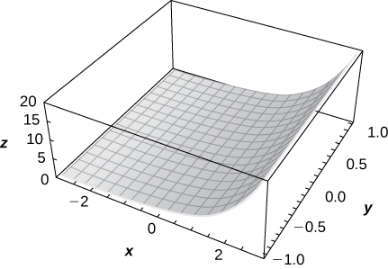

307. **[T]**

Answer: The surface is a cylinder with rulings parallel to the axis.

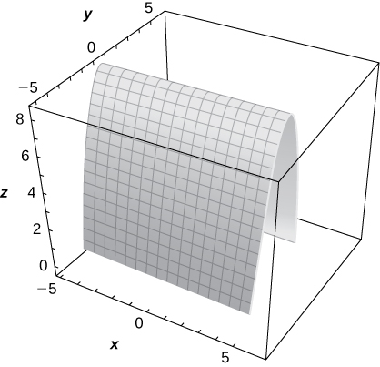

308. **[T]**

Answer: The surface is a cylinder with rulings parallel to the axis.

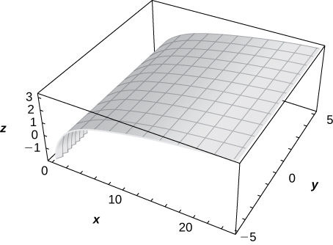

**For the following exercises, the graph of a quadric surface is given.**

1. **Specify the name of the quadric surface.**
2. **Determine the axis of symmetry of the quadric surface.**

309.

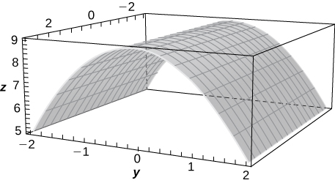

Answer: a. Cylinder; b. The axis

310.

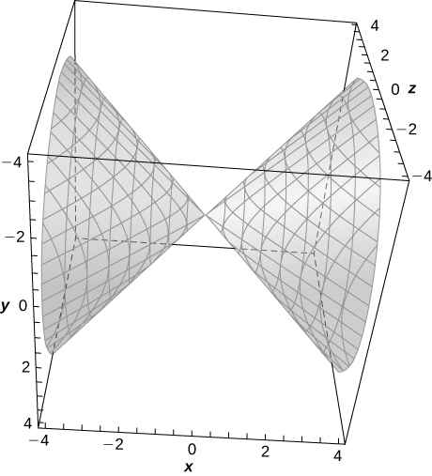

Answer: a. Elliptic cone; b. The axis

311.

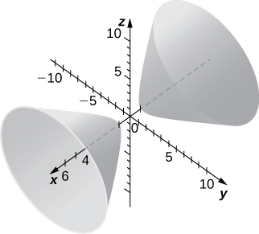

Answer: a. Hyperboloid of two sheets; b. The axis

312.

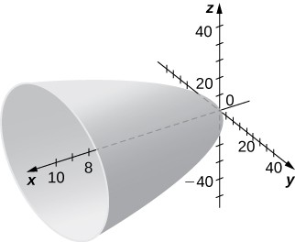

Answer: a. Elliptic paraboloid; b. The axis

**For the following exercises, match the given quadric surface with its corresponding equation in standard form.**

1. 
2. 
3. 
4. 
5. 
6. 

313. Hyperboloid of two sheets

Answer: b.

314. Ellipsoid

Answer: c.

315. Elliptic paraboloid

Answer: d.

316. Hyperbolic paraboloid

Answer: e.

317. Hyperboloid of one sheet

Answer: a.

318. Elliptic cone

Answer: f.

**For the following exercises, rewrite the given equation of the quadric surface in standard form. Identify the surface.**

319. 

Answer:  hyperboloid of one sheet with the axis as its axis of symmetry

320. 

Answer:  hyperboloid of one sheet with the axis as its axis of symmetry

321. 

Answer:  hyperboloid of two sheets with the axis as its axis of symmetry

322. 

Answer:  hyperboloid of two sheets with the axis as its axis of symmetry

323. 

Answer:  hyperbolic paraboloid with the axis as its axis of symmetry

324. 

Answer:  hyperbolic paraboloid with the axis as its axis of symmetry

325. 

Answer:  ellipsoid

326. 

Answer:  ellipsoid

327. 

Answer:  elliptic cone with the axis as its axis of symmetry

328. 

Answer:  elliptic cone with the axis as its axis of symmetry

329. 

Answer:  elliptic paraboloid with the axis as its axis of symmetry

330. 

Answer:  elliptic paraboloid with the axis as its axis of symmetry

**For the following exercises, find the trace of the given quadric surface in the specified plane of coordinates and sketch it.**

331. **[T]**

Answer: Parabola 

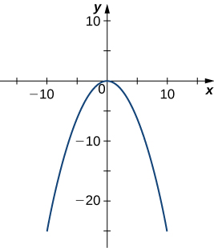

332. **[T]** 

Answer: Parabola 

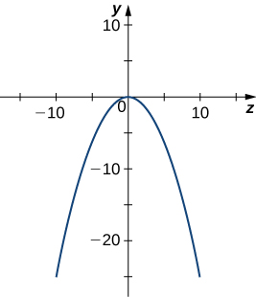

333. **[T]** 

Answer: Ellipse 

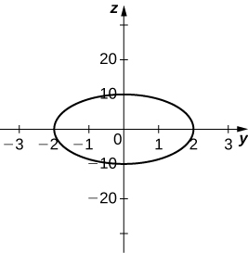

334. **[T]** 

Answer: Hyperbola 

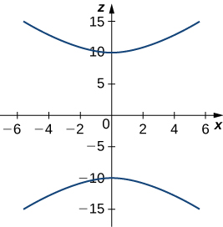

335. **[T]** 

Answer: Ellipse 

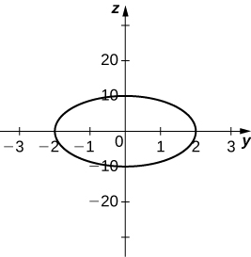

336. **[T]** 

Answer: Hyperbola 

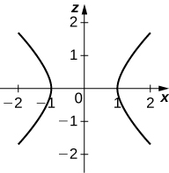

337. Use the graph of the given quadric surface to answer the questions.

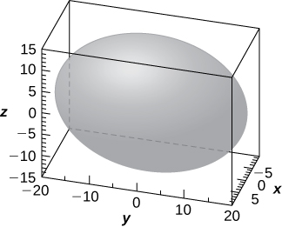

1. Specify the name of the quadric surface.
2. Which of the equations— or —corresponds to the graph?
3. Use b. to write the equation of the quadric surface in standard form.

Answer: a. Ellipsoid; b. The third equation; c. 

338. Use the graph of the given quadric surface to answer the questions.

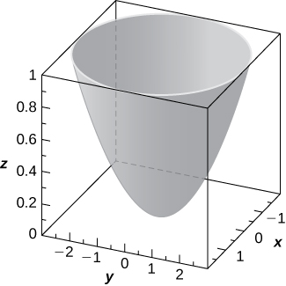

1. Specify the name of the quadric surface.
2. Which of the equations——corresponds to the graph above?
3. Use b. to write the equation of the quadric surface in standard form.

Answer: a. Elliptic paraboloid; b. The second equation; c. 

**For the following exercises, the equation of a quadric surface is given.**

1. **Use the method of completing the square to write the equation in standard form.**
2. **Identify the surface.**

339. 

Answer: a.  b. Cylinder centered at  with rulings parallel to the axis

340. 

Answer: a.  b. Hyperboloid of one sheet centered at  with the axis as its axis of symmetry

341. 

Answer: a.  b. Hyperboloid of one sheet centered at  with the axis as its axis of symmetry

342. 

Answer: a. b. Elliptic paraboloid with the axis as its axis of symmetry

343. 

Answer: a.  b. Elliptic cone centered at  with the axis as its axis of symmetry

344. 

Answer: a.  b. Elliptic cone centered at  with the axis as its axis of symmetry

345. Write the standard form of the equation of the ellipsoid centered at the origin that passes through points  and 

Answer: 

346. Write the standard form of the equation of the ellipsoid centered at point  that passes through points  and 

Answer: 

347. Determine the intersection points of elliptic cone  with the line of symmetric equations 

Answer: and 

348. Determine the intersection points of parabolic hyperboloid  with the line of parametric equations  where 

Answer:  and 

349. Find the equation of the quadric surface with points that are equidistant from point  and plane of equation  Identify the surface.

Answer:  elliptic paraboloid

350. Find the equation of the quadric surface with points  that are equidistant from point  and plane of equation  Identify the surface.

Answer:  elliptic paraboloid

351. If the surface of a parabolic reflector is described by equation  find the focal point of the reflector.

Answer: 

352. Consider the parabolic reflector described by equation  Find its focal point.

Answer:

353. Show that quadric surface  reduces to two parallel planes.

354. Show that quadric surface  reduces to two parallel planes passing.

355. **[T]** The intersection between cylinder  and sphere  is called a *Viviani curve*.

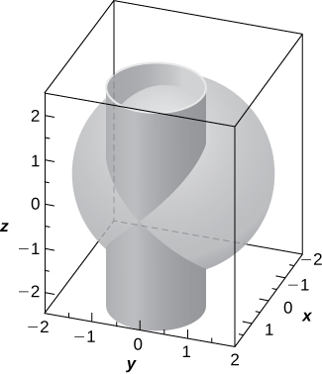

1. Solve the system consisting of the equations of the surfaces to find the equation of the intersection curve. (*Hint:* Find  and  in terms of 
2. Use a computer algebra system (CAS) to visualize the intersection curve on sphere 

Answer: a.  where 

b.

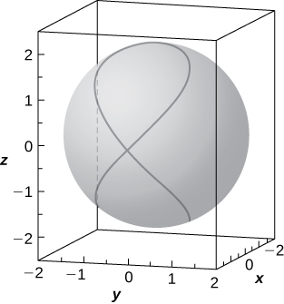

356. Hyperboloid of one sheet  and elliptic cone  are represented in the following figure along with their intersection curves. Identify the intersection curves and find their equations (*Hint:* Find *y* from the system consisting of the equations of the surfaces.)

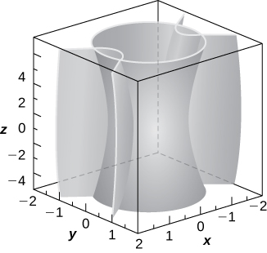

Answer: Two hyperbolas of equations  situated in planes 

357. **[T]** Use a CAS to create the intersection between cylinder  and ellipsoid  and find the equations of the intersection curves.

Answer:

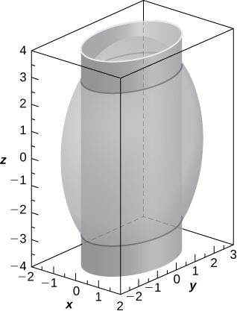

two ellipses of equations  in planes 

358. **[T]** A spheroid is an ellipsoid with two equal semiaxes. For instance, the equation of a spheroid with the axis as its axis of symmetry is given by  where  and  are positive real numbers. The spheroid is called *oblate* if  and *prolate* for 

1. The eye cornea is approximated as a prolate spheroid with an axis that is the eye, where  Write the equation of the spheroid that models the cornea and sketch the surface.
2. Give two examples of objects with prolate spheroid shapes.

Answer: a. 

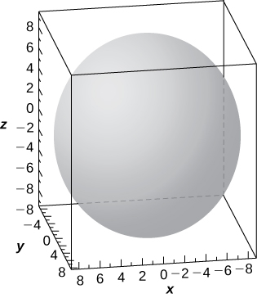

b. American football and rugby ball

359. **[T]** In cartography, Earth is approximated by an oblate spheroid rather than a sphere. The radii at the equator and poles are approximately  mi and  mi, respectively.

1. Write the equation in standard form of the ellipsoid that represents the shape of Earth. Assume the center of Earth is at the origin and that the trace formed by plane  corresponds to the equator.
2. Sketch the graph.
3. Find the equation of the intersection curve of the surface with plane  that is parallel to the plane. The intersection curve is called a *parallel*.
4. Find the equation of the intersection curve of the surface with plane  that passes through the axis. The intersection curve is called a *meridian*.

Answer: a. 

b.

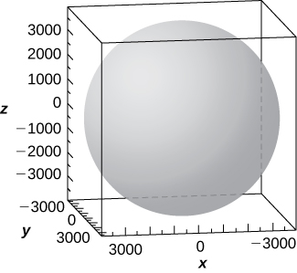

c. The intersection curve is the ellipse of equation  and the intersection is an ellipse.; d. The intersection curve is the ellipse of equation 

360. **[T]**A set of buzzing stunt magnets (or “rattlesnake eggs”) includes two sparkling, polished, superstrong spheroid-shaped magnets well-known for children’s entertainment. Each magnet is  in. long and  in. wide at the middle. While tossing them into the air, they create a buzzing sound as they attract each other.

1. Write the equation of the prolate spheroid centered at the origin that describes the shape of one of the magnets.
2. Write the equations of the prolate spheroids that model the shape of the buzzing stunt magnets. Use a CAS to create the graphs.

Answer: a. 

b.

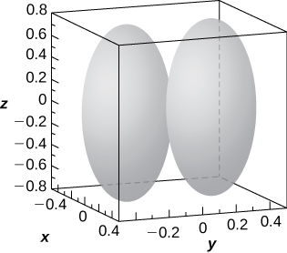

361. **[T]** A heart-shaped surface is given by equation 

1. Use a CAS to graph the surface that models this shape.
2. Determine and sketch the trace of the heart-shaped surface on the plane.

Answer:

a.

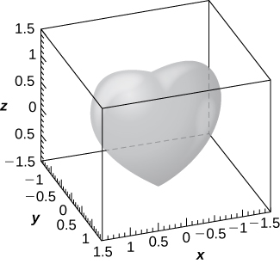

b. The intersection curve is 

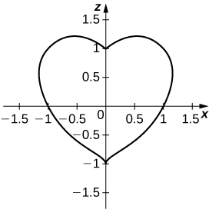

362. **[T]** The ring torus symmetric about the axis is a special type of surface in topology and its equation is given by  where  The numbers  and  are called are the major and minor radii, respectively, of the surface. The following figure shows a ring torus for which 

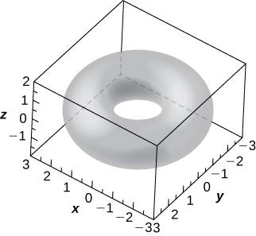

1. Write the equation of the ring torus with  and use a CAS to graph the surface. Compare the graph with the figure given.
2. Determine the equation and sketch the trace of the ring torus from a. on the plane.
3. Give two examples of objects with ring torus shapes.

Answer: a.  b.  two circles of radii  and 

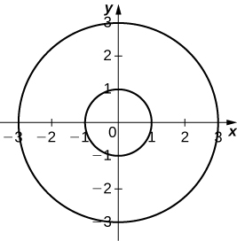

c. Donuts and inner tubes

This file is copyright 2016, Rice University. All Rights Reserved.